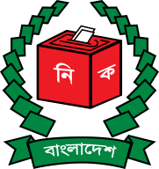

ELECTORAL SUPPORT IN 2013

1 January 2013 – 31 December 2013

United Nations Development Programme (UNDP) Bangladesh

LONG-TERM ENGAGEMENT

Strengthening Election Management in Bangladesh

Executing Agency | Election Commission Bangladesh (ECB)
Project Period | April 2011 – March 2016
Reporting Period | 1 January 2013 – 31 December 2013
Reporting Agency | UNDP Bangladesh
Project Goal | To enhance and further consolidate the institutional and professional capacities of the ECB, its Secretariat and local offices to deliver its mandated functions of conducting fair, credible and transparent elections and further consolidating itself as a permanent, professional, credible and independent institution of governance.

SHORT-TERM ENGAGEMENT

Support to the 10th Parliamentary Elections

Executing Agency | United Nations Development Programme (UNDP)
Project Period | July 2013 – June 2014
Reporting Period | July 2013 – 31 December 2013
Reporting Agency | UNDP Bangladesh
Project Goal | To support the Election Commission Bangladesh to deliver credible and technically sound parliamentary and sub-national elections and to raise public confidence in the quality of election administration and the ECB.

TABLE OF CONTENTS

List of Acronyms 5
EXECUTIVE SUMMARY 6
INTRODUCTION 8
Rationale 8
Key outcomes 9
Outcome 1: Professionalized and Strengthened Training by ETI 10
Scope of interventions 10
Planned Activities and Results 10
BRIDGE trainings 10
International Linkages, Learning and Cooperation 11
ETI’s Training Database 12
Guidelines on Training Needs Assessment 12
Outcome 2: Reform of the ECB Communications Unit and Strengthened Partnership with Stakeholders 13
Scope of interventions 13
Planned Activities and Results 13
Policy Advisory Services 13
Communication Strategy development workshop 14
Equipment of Public Relation Wing to Enhance Operational Capacity 14
Workshop on Executive Media Management, Public Speaking & Crisis Communication 14
Journalist Training: Training of Trainers (ToT) on Election Reporting 15
Establishment of Media Centre 16
Support for Voter Education Activities 16
Audio-Visual Production 16
Monitoring of the Media on Elections & ECB Coverage 17
Support to Domestic and International Observers & Media Accreditation 18
ECB Officials at the 6th Global Elections’ Organizations (GEO) conference in Korea 18
Forum of Election Management Bodies (EMB) of South Asia 19
ECB Newsletter 20
Outcome 3: Professionalized and Strengthened Information and Communication Technology (ICT) 20
Scope of interventions 20
Planned Activities and Results 20
Orientation Workshop on In-house Developed Back Office Applications’ software 20
Software’s Features: 21
Election Result Application for 5 City Corporation Elections 24
SMS for the Electors of 5 City Corporation Elections 25
Delivery of Desktop Computers at ECS 25
ECB’s website updated 25
Outcome 4: Enhanced Capacities to Prepare and Disseminate Credible and Accurate Voter Register 26
Scope of interventions 26
Voter Registration of Disadvantaged Citizens 26
Outcome 5: Enhanced Capacity to Run 2013 Parliamentary Election 27
Scope of interventions 27
Planned Activities and Results 27
Operational Training Plan 27
Trainer’s Guides 27
Election Reference Materials 28
Training Materials and Aids 28
Polling and Counting Video 29
Conduct of Operational Training 29
Monitoring and Evaluation of Operational Training 30
Training of Trainers (ToT) for Candidate Management System 31
Training on Candidate Management System (CMS) 32
Election Commissioners’ Briefing on the Results Management System (RMS) 33
Training of Trainers (ToT) on RMS for polling officials 34
Training on RMS for polling officials 34
PROCUREMENT UPDATE 35
LESSONS LEARNED 36
WAY FORWARD 36
Professionalized Training 36
Institutional Development 37
Communications 37
Strengthened ICT 37
Decentralization of voter roll 37
FINANCIAL REPORT 38
Budget And Delivery By Major Heads 38
Annex 1: Major Trainings 39
Annex 2: Documents and Publications 40

List of Acronyms

AWP Annual Work Plan
BVRS Bangladesh Voter Registration System
CEC Chief Election Commissioner
CTG Caretaker Government
DFID Department for International Development
ECB Election Commission Bangladesh
ERD Economic Relations Division
ETI Electoral Training Institute
EU European Union
ICT Information Communication Technology
IDEA Identification System for Enhancing Access to Services
GoB Government of Bangladesh
LVRS Local Voter Registration System
NNEB Network for National Election Management Bodies
NPD National Project Director
PERP Preparation of Election Rolls with Photograph
RPO Representation of People’s Order
QWP Quarterly Work Plan
SBS Step-by-Step Guide
SEMB Strengthening Election Management in Bangladesh
SEPB Support to the Electoral Process in Bangladesh
SPE Support to the 10th Parliamentary Election
TBB Translucent Ballot Boxes
UP Union Parishad
UNDP United Nations Development Programme
USAID United States Agency for International Development

EXECUTIVE SUMMARY

UNDP Bangladesh, in line with its global mandate to provide electoral assistance in promoting genuine democratization, is supporting the Election Commission Bangladesh (ECB) through a long-term technical and advisory partnership. UNDP’s electoral assistance involves both short-term operational support to specific election events, as well as support to longer-term processes such as capacity development of the country’s election management body.

In 2013 UNDP Bangladesh provided both a long-term capacity building support to the ECB with a particular focus on strengthening the institution, and a short-term support for 10th Parliamentary elections conducted on 5 January 2014. The support was provided through a multi-year Strengthening Election Management in Bangladesh (SEMB) project and a short-term Support to 10th Parliamentary Election project, both of which have contributed to further strengthening the organizational and human resources’ capacity of the Commission.

Particularly, the UNDP projects assisted the Commission and its Electoral Training Institute (ETI) to design and implement operational training of 307,928 electoral officials aimed at enhancing their technical knowledge and capacity to conduct polling and counting procedures in a professional, impartial and transparent manner. Further, in-house training capacity of the Institute and the Commission was improved thorough participation of 95 election officials in the BRIDGE trainings during which four staff of the ECB were accredited as international BRIDGE facilitators.

With the support of both UNDP initiatives, the ICT wing of the Commission developed the Result Management and Candidate Management Systems (RMS/CMS) enabling the ECB to manage candidate information and the election results with more transparency and effectiveness. The ICT wing also conducted training of 1,200 users who were deployed at the field during elections.

UNDP also assisted the Commission in improving its outreach to electorate to enhance voters’ knowledge about their political and democratic rights. During the reporting period voter awareness campaigns were organized in all seven divisions of the country. These awareness campaigns were targeted on first time voters, women and other groups vulnerable to the problems in election process including voters living in slums and remote areas (e.g. Chittagong Hill Tracks). A number of voter education materials were distributed by the ECB countrywide.

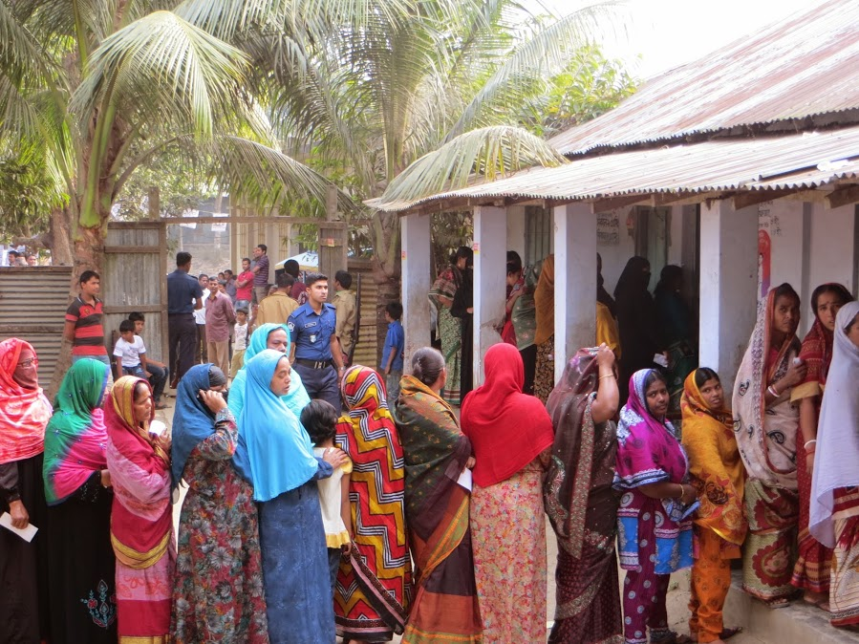

INTRODUCTION

Bangladesh has a parliamentary form of government with a multi-party system. Under the constitutional scheme there are 300 members of the national parliament (Jatiya Sangsad) elected from single-member constituencies by direct election. Elections are based on a single member majority system (First Past the Post) in which the candidate garnering the largest number of votes is declared the winner. There are no thresholds that must be met, and no absolute majority or turnout requirements. In addition to the 300 elected members, there are 50 reserved seats exclusively assigned to women. These members are selected by the 300 elected parliamentarians.

Although Bangladesh has held national elections since 1973, very few of the electoral exercises lived up to international standards for free and fair elections. Rather, various fraudulent methods were employed to ensure that a ruling party would consolidate and maintain its lock on power. To overcome the dysfunctional consequences of holding elections under party governments and to create an environment in which free and fair elections can be held without undue political influence, the caretaker government (CTG) was introduced in Bangladesh in 1990. Since then, the CTG managed elections and transitions from one elected government to another in 1996, 2001 and 2008. However, the legal provision mandating the formation of the CTG to oversee general elections was abolished through the fifteenth amendment to the Constitution in 2011. In absence of a neutral caretaker administration and the resulting deteriorating confidence of opposition parties in the electoral system, the importance of planning and implementing proper election procedures in a fair and transparent manner, which, if followed, would confirm the professional legitimacy of the election, was particularly critical in the 10th Parliamentary polls.

Recognizing this important element of the 10th legislative elections and in line with the electoral cycle approach, UNDP provided technical assistance to the Election Commission Bangladesh (ECB) through its Strengthening Election Management in Bangladesh (SEMB) and Support to the 10th Parliamentary Election projects.

Rationale

Successful democratic elections provide each citizen with the equal right to vote for their leaders. This right is enshrined in the Universal Declaration of Human Rights and the International Covenant on Civil and Political Rights, which are binding international instruments to which Bangladesh is a party. As elections are critical to holding leaders accountable for their decisions, they have significant implications for the quality and nature of governance, for alleviating poverty and for the promotion of sustainable development.

While elections are fundamentally the responsibility of the country holding them, Bangladeshi own institutions have recognized that there is a significant need to improve electoral democracy. The government of Bangladesh (GoB) has specifically requested UNDP to provide assistance in strengthening electoral institutions and processes in the country. In 2013 such assistance has been provided through (1) a multi-year Strengthening Election Management in Bangladesh (SEMB) project aimed at supporting national efforts to entrench good electoral practices and enhance national electoral capacities in a long-term, and (2) a targeted short-term Support to the 10th Parliamentary Election (SPE) project aimed at supporting elections preparation in a lead-up to and during the 2014 national legislative polls.

Specifically, UNDP aimed to provide expert technical assistance and operational support to the ECB through the SPE project, primarily directed at addressing immediate priority needs related to the successful conduct of the 2014 legislative polls. Strategic support provided under the SEMB project focused on building a sustainable and enduring institutional and professional capacity within the Commission, stretching beyond technical assistance specifically targeting the conduct of the 10th Parliamentary elections.

A simultaneous focus on addressing the EBC’s immediate and longer term priority needs allowed UNDP to respond flexibly to shifting needs and opportunities in improving the quality of elections within the broader context of strengthening democracy in the country. Further, it ensured that election officials adequately absorb requisite capacities and professionalism necessary to deliver a technically well-administered election event, and are able to retain such capacities over multiple electoral cycles.

Key outcomes

As mentioned above, the SEMB and SPE projects were designed to provide expert technical assistance and operational support to the ECB primarily addressing the immediate priority needs closely related to the successful implementation of the forthcoming cycle of electoral events – namely the 10th Parliamentary elections – and long-term institutional strengthening and professional development assistance to the Commission. To this end, the projects were envisioned to achieve the following outputs:

- ETI is able to provide professionalized and strengthened training to electoral officials;
- Capacity of ECB communication wing for better communications and voter education is enhanced;
- The ECB is able to transparently manage candidate information and election results through deployment of Result and Candidate Management Systems;
- The ECB has better managed logistics, coordination, procurement and production of relevant materials.

Outcome 1: Professionalized and Strengthened Training by ETI

Scope of interventions

The training component aims to strengthen the institutional and human resource capacity of the Election Commission Bangladesh (ECB) and its Electoral Training Institute (ETI) to enable the organization to better formulate its own capacity building strategy, enhance internal trainings delivered to election officials, and improve electoral resources for the ETI and ECB.

To ensure sustainable outcomes, the activities during the reporting period centered on improving the level of ETI’s and ECB’s staff skills, knowledge and understanding through trainings, development of capacity building tools and mechanisms, and on-job mentoring. Targeted capacity building inputs along with on-going guidance provided to ECB and ETI by SEMB experts have led to overall improvement in staff technical knowledge and skills throughout the organization.

Planned Activities and Results

BRIDGE trainings

Marked progress was made in developing skills and knowledge of election officials through the conduct of four BRIDGE trainings in 2013. The trainings were aimed at enhancing the professional knowledge and skills of ECB officials and election stakeholders at various levels in a long term, and raising their awareness of international principles and best practices in election administration. A total of 95 participants including representatives from the Election Commission (both from the Secretariat and the field offices), ETI, and other election stakeholders such as civil society, political parties and women’s groups attended the trainings. The trainings also led to full BRIDGE accreditation for four ECB staff who are now authorized to use BRIDGE materials, and utilize them in delivering their own trainings to the staff of the Commission and external stakeholders.

 | BRIDGE Module | Date of training | Total number of participants | Number of female participants | Number of accredited facilitators
1 | Pre-election Activities | 14-16 May | 24 | 4 | 0
2 | Pre-election Activities | 4-6 June | 23 | 3 | 2
3 | Gender and Election | 17-20 June | 27 | 13 | 2
4 | Electoral Training | 24-27 June | 21 | 1 | 0
Total |  |  | 95 | 21 | 4

- BRIDGE module on Pre-Election Activities: SEMB project organized BRIDGE training on Pre-Election Activities for two batches of election officials in May and June 2013. Interactive method of training allowed the participants to quickly grasp the major principles of election administration in pre-election period. Particularly, the participants gained an understanding of complexity of the logistical operations of elections, importance of a thorough planning of all aspects of elections, and learned the tools for developing a logistical plan

- BRIDGE module on Gender and Elections: UNDP, UN-Women and the Embassy of Sweden have jointly organized a three-day training for election officials, representatives of civil society and political parties, and other election stakeholders on gender and elections. The agenda of the workshop covered political parties’ role in gender equality, candidate nomination processes, gender quotas, and international standards. Participants particularly engaged with questions of representation over the issues of reserved seats. One of the highlights of the workshop was a set of case studies on the experiences of quotas in countries with similar electoral systems.

- BRIDGE module on Electoral Training: SEMB project conducted a two-day BRIDGE workshop on Electoral Training for ECB staff primarily from district and upazila level election offices in June 2013. In a course of the workshop participants learned principles of electoral training, implementation methods and approaches including needs assessment, development of training plans and strategy, as well as concrete training and facilitation skills. The training was structured in such a way that it combined presentations and learning sessions, role-play games and discussions of issues that participants may face in their work. The participatory and interactive methodology of the training was particularly appreciated by the participants.

International Linkages, Learning and Cooperation

In addition to the BRIDGE trainings, the project strengthened capacity of election administrators through organizing various events and study tours. Particularly, two senior ECB representatives (the Commissioner and the Deputy Secretary) attended the South Asian Forum on Civic, Electoral and Voter Information in Thailand in February 2013. The other two election officials – the ECB’s Additional Secretary and the District Election Officer – participated in the training course on Electoral Processes in the United Kingdom in March 2013 that led to their accreditation at level 5 of the London-based Chartered Management Institute (CMI).

Study visits and tours allowed for exposure to and exploration of other countries’ experiences in preparation and conduct of elections, and stimulated participants’ consideration of applying good practices to electoral operations in Bangladesh.

ETI’s Training Database

Responding to the ETI’s need in establishing a systematic training management system, the SEMB project designed a Training Database Management System (TDMS). The development of the system followed a participatory process where ETI officials were briefed on the principles and approaches in design and utilization of training management systems, and clarified their requirements for such a system. The TDMS developed by SEMB experts allows the following features:
- Searching individual staff data including previous trainings received;
- Generating history of trainings received and/or conducted by a facilitator/trainer;
- Generating statistical training reports disaggregated by gender within a specified time period;
- Flagging overlapping assignments (e.g. the system does not allow the assignment of the same facilitator/trainer to training programmes with an overlapping timeframe);
- Generating audit log with description of the system’s transaction data.

Currently the ETI officials are utilizing the database for the systematic processing and storage of training information including data on trainees, trainers, courses, training reports, etc. The TDMS has enhanced the management of trainings and has contributed to making them more efficient and structured.

Guidelines on Training Needs Assessment

In order to enhance the ETI’s capacity to systematically assess and address the training needs of the Commission, the SEMB project developed the Guidelines for Training Needs Assessment (TNA) and shared the document with ETI. The Guidelines describe TNA methodology, steps in preparing and conducting TNA, and compiling TNA report. An introduction of a proper TNA process allows an acquisition of specific skills and knowledge to ETI officers to understand problems being faced by the ECB staff in performing their tasks; to find out the gaps in training and capacity development (TCD); to identify the new requirements of ECB staff as the electoral environment in Bangladesh evolves; to help prioritize the contents of the training; and to map the expectations of electoral stakeholders on how the electoral administration and management should perform. The TNA Guidelines are being utilized by the ETI in planning and developing training strategies and programmes for the Commission’s staff.

Outcome 2: Reform of the ECB Communications Unit and Strengthened Partnership with Stakeholders

Scope of interventions

SEMB initiatives promoted increased transparency of the ECB and its ability to engage and partner with national electoral stakeholders. It also served to raise the level of voter awareness on electoral procedures and processes.

Planned Activities and Results

Policy Advisory Services

Support was provided to ECB to develop and implement its external communication strategy. The strategy focused on improvement of the media relations and engaging the media in a more systematic way. The enhancement of public perception of the Commission through increased public outreach with key stakeholders-media, CSOs, NGOs, political parties and donors was also a target in the strategy. The communication Strategy is one of the most important elements to help establish the credibility of ECB with political parties, civil society, the media and the electorates. Moreover, the strategy provides guidance and encourage discipline, which will aid the ECB in more clearly considering its objectives and the messages to stakeholders during various phases of the electoral process and different audiences for those messages.

Strategic Communication allowed the ECB to integrate all its communications work - not just media relations, but also voter education and information, public outreach, contacts with political parties, CSOs and other stakeholders. This document also allowed members of the Commission, high officials of the Secretariat and assigned staff to communicate a coordinated message to the stakeholders.

The comprehensive communications plan contributed to focusing available resources, both human and material, on the areas most important to the Commission. It helped the ECB to develop a toolkit of techniques and measures that it could use in its engagement with stakeholders in a timely and efficient manner. The ECB is better able to marshal its resources by preparing materials for distribution to the media, CSOs, political parties and other stakeholders. The plan also allowed the Commission to be more systematic and effective in its voter education initiatives.

In the implementation of the activities of the strategy emphasis was placed on the development of simplified targeted messages and production of corporate folders and informational materials to improve the visibility and credibility of the Commission. These public outreach strategies and promotional material contributed to improved transparency in the electoral process and the Commission in general.

Communication Strategy development workshop

The SEMB project organized a two-day workshop "Development of Communication Strategy” on 30-31 May 2013. A total 20 ECB officials and project staff attended the workshop including six females. Communication Specialist of SEMB project facilitated the key sessions of the workshop and provided explanation on the goal of strategy and its importance to the Commission. SWOT analysis of present situation of ECB was undertaken. The SEMB expert also facilitated discussion on different stakeholder and communication methods/ tools/ channels in order to develop and effective and targeted outreach plan. The workshop was very interactive and the group-work and brain storming sessions allowed participants to contribute to the development of the strategy so that there is a better ownership of the document.

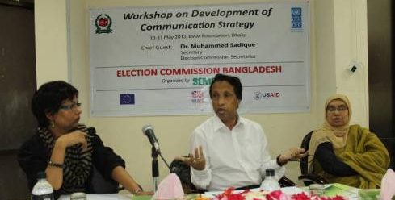 | 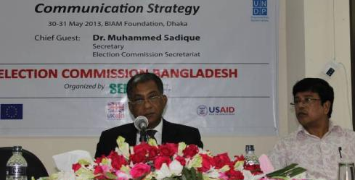

Equipment of Public Relation Wing to Enhance Operational Capacity

The project provided critical equipment to the Public Relations Wing of ECB to bolster its day-to-day management and operations in communications and media management. The equipment provided included two laptop computers, three television sets, still and video cameras, multi-function printer, and furniture to enhance the space and use by staff and public.

Workshop on Executive Media Management, Public Speaking & Crisis Communication

The ECB with the support from SEMB implemented a four-day workshop “Executive Media Management Public Speaking & Crisis Communication” on 11-14 November 2013. The Secretary, Dr. Muhammed Sadique together with the Additional Secretary, Md. Sirazul Islam, the Joint Secretary, Ms. Jesmin Tuli and all high officials of ECS participated. The main purpose of the workshop was to enhance the skills of the ECB to respond to the media and analyses issues in a more systematic way. A senior trainer from Reuters, Mr. Royston Martin, conducted the training utilizing a variety of adult learning approaches.

The focus of this workshop was 1) Strategic Messages and 2) Crisis communication interviewing techniques. Participants were given fundamental principles of strategic media management especially as it relates to developing core messages.

Through successful specialized training on media management participants were provided with required skills and tools to change attitudes and related behaviors towards the media. As such, this has inspired appropriate enthusiasm for the nuances of communicating effectively with reporters as well as highlighting the infinite and often frustrating complexities of media and crisis management.

The workshop was highly interactive and provided participants with the opportunity to take part in role-play so that they are better prepared to handle crisis. Individual time was given to each participant to practice the interviewing technique. They were given difficult questions and had the see replay and learn from instant.

The training was implemented at a crucial time before the 10th Parliamentary elections. The Commission is now better equipped to deal with the media and plan strategically in an efficient manner. Participants expressed the appreciation for the workshop and said they have benefited tremendously from it. The workshop has provided them with the key tools and skills to manage the media and respond to crisis in an efficient manner.

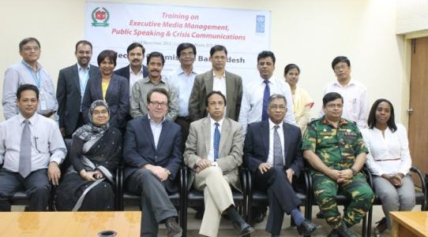 | 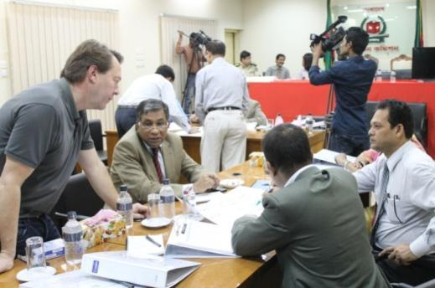

Journalist Training: Training of Trainers (ToT) on Election Reporting

Capacity building of media professionals through targeted training on basic journalism skills and elections coverage is crucial in enhancing their abilities to carry out a professional job during elections. UNDP has been providing technical and financial support in implementing training programme for the journalists. UNDP in partnership with the Department of Films and Publications (DFP) organized a ToT on 18-21 November 2013. A total of 23 senior journalists from renowned print and electronic media and professors of Public University’s Journalism Department participated in the training. During the four-day training a handbook on “Reporting on Parliament Election” was also developed. Trainers from the Reuters were hired to conduct this ToT. As part of journalist training, 10 workshops on “Effective Election Coverage” have been planned to be conducted for 400 Journalists across 10 electoral regions.

Establishment of Media Centre

The SEMB project supported the ECB with the establishment of a Media Centre. The aim of this initiative is to increase the level of quality coverage on ECB by enhancing the Commission relations with the media and this will lead to an enhanced professionalism and overall improved image and visibility of ECB.

The media center was launched 4 January 2014. Support was provided for procurement of equipment and furniture as follows:
- Internet Connectivity Modem and wireless Router
- One Sound System with install microphone and two wireless microphones
- Two Multi-media Projector with screen
- Two Computers
- Two Television sets (42”)
- Sound System for Public Address
- 50 chairs
- Seven Executive chairs for Head table
- Two head tables
- One Bookshelf
- Wooden Podium

Support for Voter Education Activities

The project provided support to the Commission to develop and implement a Voter Education strategy and action plan. In this regard, the ECB’s PR Department, in close cooperation with the SEMB team reviewed existing material and further developed printed and broadcasted materials that set out the key elements of the electoral process. The communication team of SEMB assisted with providing expertise including drafting, editing, and graphic design for this to be done.

Audio-Visual Production

Information offered in audio and audio-visual formats is more powerful than just written information, especially given low levels of literacy in rural areas in Bangladesh. Effort was also concentrated in three areas as follows developing and producing audio-visual messages for broadcast on television. With the expansion of Bluetooth smartphones, SMS in the form of Public Service Announcements (PSAs) were distributed via several telephone service providers. Videos or dramas illustrating important steps in the electoral process were produced as effective means of delivering important information to communities in rural Bangladesh.

In this regard support was also provided to the Commission for developing and production of Voter Education materials, which included:

N/n | ITEM | QUANTITY
 | Voter Education Handbook | 20,000
 | 15-page Flipchart | 20,000
 | Pocketbook on Guidelines for International Observers | 2000
 | Guidelines for Local Observers | 300,000
 | Three Leaflets on Conduct for Political Parties | 400,000
 | Two Posters (Support Peaceful Elections) | 200,000 each
 | One Poster on Marking of the Ballot Paper | 500,000
 | Poster on explanation of the Polling Process | 500,000
 | Four sets of Bumper Stickers with Election slogans | 1,000,000
 | Two Factsheets and brochures | 300,000
 | International Observer Cards | 2,000
 | Local Observer Cards | 300,000
 | Cards for Interpreters | 2,000
 | Media Accreditation cards | 50,000
 | Vehicle Stickers: Media, Observers and ECB Officials | 200,000

Monitoring of the Media on Elections & ECB Coverage

SEMB project supported the Election Commission Bangladesh with the media monitoring exercise for the coverage for 10th Parliamentary elections. In this regard, MRDI, which is a private but prominent media monitoring company in Bangladesh, was hired and monitoring was done for twelve weeks commencing from the 2nd week of November 2013 and concluding on 21 February 2014.

The media monitoring firm included coverage of news of the key media outlets at national and divisional levels, reflecting a representative sample of the media in Bangladesh. Both qualitative and quantitative monitoring and analysis of print, electronic and online media was undertaken to assess whether the elections were covered in a professional, fair and impartial manner; the type of coverage for elections: informative; voter education or propaganda; whether political actors received equitable and balanced coverage by the observed media outlets both in terms of space-time allocation and tone; whether the agenda of the media fairly reflected issues and themes relevant to elections.

MRDI provided daily news summaries and a synopsis of the coverage given to the Commission. The information collected by the firm was analyzed to determine media in a role as agents of pacification or agitation in the highly charged political environment. Additionally, the Chief Election Commissioner (CEC) requested summarized analysis of the main news covered by the 10 daily newspapers relating to electoral process and the Commission. The 1-2 page write-up was submitted by 10:00 am each day providing the CEC with the option to plan his daily action regarding media relations, such as issuing of rejoinder, statement, press note, clarification or taking necessary measures.

In addition to the daily news summary, weekly and monthly reports were also provided to the Commission. MRDI also supported the Commission with efficient media monitoring by providing the TV news coverage and talk shows relating to the Commission on DVDs so that they had easy access when required. This information was also available on MRDI server.

Support to Domestic and International Observers & Media Accreditation

The Commission was given assistance by the project to provide support to media, local and international observers. This was to enable the Commission to enhance the efficiency and effectiveness in election observation.

More specifically, support was provided for the production of accreditation cards for local and foreign media, as well as accreditation cards for local and foreign observers. Information packs were also provided for foreign observers, which included branded materials such as ties, folders and notepads, tourist guides and maps, and factsheets.

ECB Officials at the 6th Global Elections’ Organizations (GEO) conference in Korea

Four senior officials of the Election Commission Bangladesh attended the 6th GEO conference in Korea from 14 -17 October 2013. This is one of the largest gatherings of Electoral Management Bodies (EMB) in the world. The ECB hosted a booth at the Knowledge Fair providing information on its biometric voter list and registration process, electronic voting machines, its strategic planning documents including training manuals. A total of 405 electoral experts (Chairperson, President, Commissioner, Secretary-General of Election Management Bodies; 14 international organizations and 39 NGOs) from around the world participated in the GEO conference. The meeting covered topics related to Sustainable Electoral Integrity, Addressing the Marginalization and Exclusion of Women; Countering Fraud and Manipulation and Electoral Violence, Capacity Building and Professional Development of Election officials; Stakeholder Relationship; Assessing sustainable ICT, Promoting cost-effectiveness in electoral process, and others. The participants from the ECB who attended the GEO Conference were Mr. Md. Zabed Ali, the Honorable Commissioner; Dr. Muhammed Sadique, the Secretary of Election Commission Secretariat; Mr. Sirazul Islam, Additional Secretary of ECS, and Mr. SM Asaduzzaman, Head of the PR Wing.

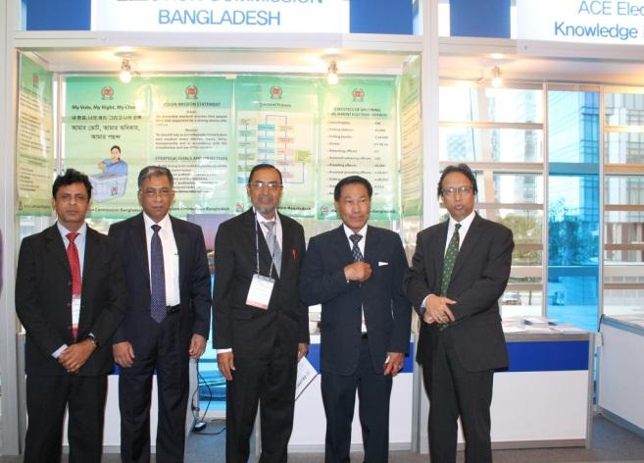

Forum of Election Management Bodies (EMB) of South Asia

Support was provided to the Election Commission Bangladesh to create logo for SAARC EMB, which is a newly formed forum. A request was made by the chairperson of this forum and Chief Election Commissioner of India Election Commission for ECB to support the development of the logo. This decision has been made at the 3rd conference of Forum of Election Management Bodies (EMB) of South Asia in India.

After that ECB publicly circulated announcement to design the logo. After evaluating all logos, ten have been selected and sent to the Forum of Election Management Bodies (EMB) of South Asia on 11 June 2013. For this initiative, SEMB provided technical and financial support and also facilitated tendering and evaluating process.

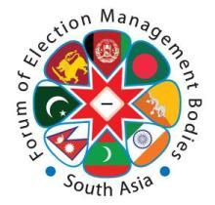 | 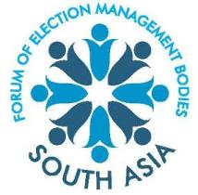
 | 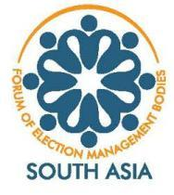

ECB Newsletter

To promote transparency of ECB activities, a quarterly Bangla newsletter entitled “Commission Barta” was regularly produced and distributed to a range of electoral stakeholders. SEMB provided technical input leading to the newsletters production and 8000 copies have been printed by end of the year 2013. Production and printing of an English version of the newsletter is under way to be distributed to donors and other partners.

Outcome 3: Professionalized and Strengthened Information and Communication Technology (ICT)

Scope of interventions

SEMB interventions enhanced BEC ability to utilize ICT in election management and to use it for greater organizational efficiency.

Planned Activities and Results

Orientation Workshop on In-house Developed Back Office Applications’ software

The SEMB Project organized a two-day workshop on 25-26 May on "In-house Developed Back Office Applications”. Three software modules for Election Commission Bangladesh (ECB) have been developed by ICT team of SEMB. Three software modules are (a) Inventory Management of Election Materials; (b) Election Budget Management; and (c) City Corporation, Pourasava & Union Parishad Election Schedule Application. The purpose of this software is to modernize and automation of electoral system of ECB.

A total of 36 senior and mid-level officials from Election Commission Secretariat (ECS) and field offices (ECS key staff, REO, DEO, NID’s key staff and ECB IT key staff) have participated in this workshop. The workshop was able to create huge interest among the participants in using the developed software modules. The participants felt that these software modules will help them carrying out day-to-day office work promptly and in an accurate way.

Software’s Features:

Inventory Management of Election Materials

- Types of election materials needed;
- Quantities of materials needed;
- Where materials are to be used (in what type of election);
- What materials are available and what materials need to be refilled;
- Generating & printing delivery chalan;
- Generating & printing item-wise balance sheet

The following screen-shot from the election material inventory application shows which election materials need to be replenished immediately as they have gone below the desired stock level:

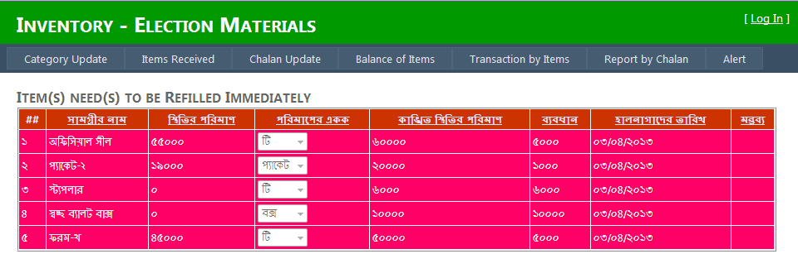

The following screen-shot from the application shows the transaction (balance sheet) of an election material within a date range:

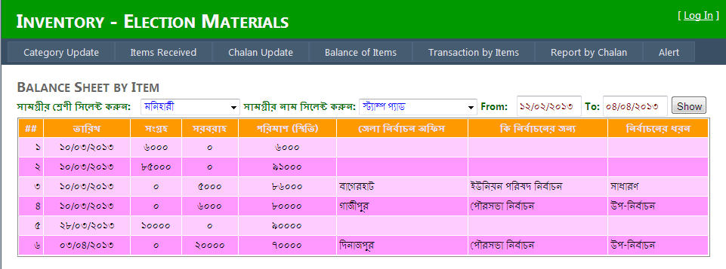

B. Election Budget Management

- Preparing and calculating estimates of likely income, expenditure, assets and liabilities;
- Preparing and monitoring election budget;
- Monitoring and controlling expenditure;
- Keeping track of budget allocation, expenditure and reconciliation;
- Generating regular financial report and/or on an ad-hoc basis;
- Facilitating auditing of the financial processes.

The following screen from the application shows money allocated in different budget lines for conducting elections:

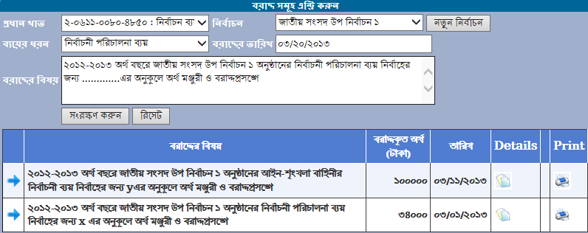

C. Pourasava & Union Parishad Election Schedule Application

- Generating & printing reports of which pourasava/union parishad’s tenure expire when;
- Generating & printing statistical reports of conducting pourasava/union parishad’s election within a specified period of time;
- Forecasting how many pourasava/union parishads’ election need to be conducted within a specified period of time;
- Generating & printing statistical reports of conducted elections (pourasava/union parishad) by types of election such as general, by-election etc.
- Finding the election status of individual poursava/union parishad such as reasons for not holding election on a scheduled time.

The following screen-shot shows the present status of all pourasavas depicting how many pourasavas’ election cannot be held due to various legal disputes and which elections are forthcoming:

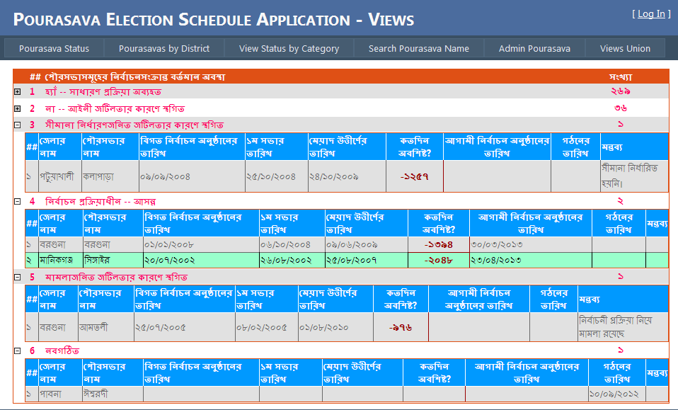

D. Institution Database as a polling center

This software help to get the information of polling institute so that it can easily create a basic idea of the institution based on the condition with different parameters and also helpful for upcoming elections for listing the polling institution.

Features of the Software:
- Name of the institution
- Location of institution (Zilla/Upazila/Municipality/Union)
- Total number of room
- Types of the building
- Contact number of the head of organization
- Number of employees
- Condition of electric facility/toilet facility/transportation
- Is there any demarcation boundary/Open space?
- If no boundary then what is the surroundings scenario of the institution
- Distance between election offices (Kilometer)
- Is this institution considered as risky zone in past?

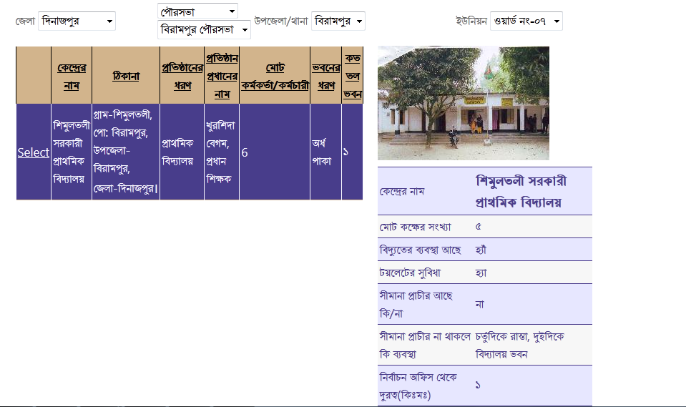

Election Result Application for 5 City Corporation Elections

Election Result Management Application for 5 City Corporation Election has been developed and deployed, and it was used successfully during the elections on 15 June 2013. The SEMB ICT team provided technical support in developing the system of Election Result Application for sending the result through the intranet system using excel based software application. ICT Team provided a special spread sheet for accumulation of center-wise result and sent data immediately to the server. In this election only mayoral candidates result data was processed using this system. User generated the progressive result as well as automatic polling center result accumulation at a time in offline mode and sent result data to server so that the head office could be up to mark about the result. The sheet can synchronize with the server on connection. On the server end, there was a controller service application to receive the result data from the local area and place it to server and a store every entry log in the server.

Everybody in the election commission secretariat observed the result of the 4 city corporations in their internal VPN network. The live result report was shown continuously by the projector in five city corporation result declaring zone so that people can view summary and center wise result on a large screen. The Secretariat officials continuously observed the live result using this system.

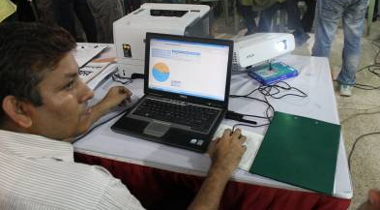

SMS for the Electors of 5 City Corporation Elections

Voters often face challenges to find out the polling center and voter ID number because each voter has NID card but s/he could not know what his/her voter number is. As a result, voters depend on different informal sources for getting polling center information (e.g. political party representatives who are routinely provide “voter information slips” on Election Day). At the same time, the ECB has an obligation to provide voters with this information. For this reason, the SEMB project provided technical support to develop voter SMS feature by using NID card number. Assumption of this system was that most of Bangladeshi people have used mobile phone in high frequency. In this system electors easily get their polling center information along with voter ID number by sending SMS using NID card number. This SMS feature for the electors of 4 City Corporation Elections has been implemented successfully prior the elections. For greater dissemination purpose of this feature, ECB could send SMS information to each and every voter by SMS in all places of 4 City Corporation Elections area. This SMS service provide by BTRC (Bangladesh Telecommunication Regulatory Commission) on a voluntary basis. In some places local election office could have announced this information through advertisements in local newspapers.

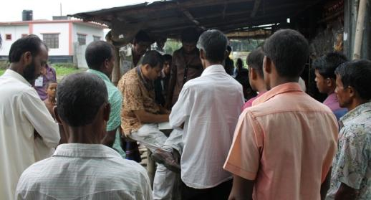

Delivery of Desktop Computers at ECS

SEMB project has amid to support the ECB for capacity strengthening in terms of human resources and infrastructure (IT equipment, different logistic). In relation to that, a delivery of 25 desktop computers to ECS has been completed and in this regard ICT equipment acceptance report has been prepared in collaboration with the ICT personnel of ECS.

ECB’s website updated

The SEMB ICT team has been working to support the Commission to enhance its official website (http://www.ecs.gov.bd). The Commission intends to utilize the website to enhance its transparency and to disseminate crucial information to the public in the run-up to, during and after the elections. The support for enhancement has included the update of the contents, improved navigation, increased functionality such as a comments section to accept public feedback, and others.

Outcome 4: Enhanced Capacities to Prepare and Disseminate Credible and Accurate Voter Register

Scope of interventions

The electoral law requires that the voter list is updated in January of every year and also allows for continuous voter registration. In this light, SEMB project supported the nation-wide update of the voter list in 2012 to ensure that a credible voter roll can be maintained. This was done ahead of the 10th Parliamentary elections, and to further promote and consolidation the results of the PERP project, which successfully delivered one of the most complete and accurate voter list in the country’s history. At same time, SEMB initiatives promoted the decentralization of the voter registration system, in line with ECB Strategic Plan and provided technical know-how to enhance the continuous voter registration system.

Voter Registration of Disadvantaged Citizens

Following the assistance provided by the SEMB project to the Election Commission to register 7 million new voters (taking the total registered voters to 92 million), the project worked to ensure the continued inclusiveness of the list in 2013. In partnership with the UNDP poverty reduction project (UPPR) and Chittagong Hill Tracts (CHTDF) projects, SEMB facilitated information sharing on the continuous voter registration process and encouraged the registration of slum dwellers, the homeless and indigenous people who were out of registration. To ensure maximum inclusiveness, the Election Commission maintains a continuous and decentralized registration process, where all eligible voters can register to vote until the declaration of the election schedule. Additionally, fact sheets on voter registration are being produced to enhance public information on the voter list and the registration process.

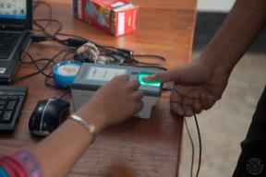

Outcome 5: Enhanced Capacity to Run 2013 Parliamentary Election

Scope of interventions

In a run up to the 10th Parliamentary election, significant efforts were made in supporting the ECB and ETI to develop and implement operational training of election officials. Particularly, technical advice and assistance was provided to the Commission and the Institute in design and development of training session plans and election reference materials (manuals and guidelines) based on adult learning principles and methodology, as well as the actual conduct of electoral training events at various tiers.

The professional training of election officials at every level expanded knowledge and skills of ECB staff so that they could complete their duties in a competent manner and, therefore, added considerable capacity to the Election Commission to administer the 10th Parliamentary election smoothly, consistently and transparently.

Planned Activities and Results

Operational Training Plan

The SEMB project provided technical advice and assistance to ECB and ETI in development of operational training plan utilizing the cascade type methodology. Training activities envisioned in the operational plan were designed to provide competencies to the senior staff supervising polling personnel, and poll workers directly in contact with voters including 68 Returning Officers (ROs), 583 Assistant Returning Officers (AROs), 42,000 Presiding Officers (PrOs), 212,500 Assistant Presiding Officers (APrOs), and about 425,000 Polling Officers (POs) totaling to some 700,000 electoral staff. The operational training plan outlined the objectives and strategy of the training, described methodology and target audiences, as well as the subject areas, contents and materials required for training sessions. It also introduced a new interactive training methodology based on adult learning principles.

Trainer’s Guides

In order to enhance the uniformity and professionalism of electoral training and usher in modern ways of training delivery, the SEMB project developed two Trainers’ Guides for (1) training of Presiding Officers and Assistant Presiding Officers, and (2) training of Polling Officers consisting of 16 and 11 training sessions respectively. The Guides featured several key components including training agenda, detailed step-by-step session plans, and identification of objectives, methodology, and necessary training materials and aids for each session.
Within each session plan innovative training styles were introduced to encourage departure from traditional lecture methods. Interactivity and audience participation were promoted through group exercises, role-plays, demonstrations, and breakout discussion groups. Sample energizers and brain games were offered at the end of the Guides to liven up and recharge the participants when their energy could be low and motivation is decreasing. The Trainers’ Guides were also supplemented by pre- and post-training quiz to measure participants' general understanding of the material and preparedness to conduct the poll; as well as an evaluation questionnaire to assist ETI staff and trainers to measure the effectiveness of the training program and to determine where improvements or modifications are needed.

Election Reference Materials

To ensure uniform knowledge of the election process, regardless of past service as an election official, attendance of operational training or educational background of a poll worker, the SEMB project developed two election reference materials: (1) Manual for Presiding Officers and Assistant Presiding Officers, and (2) Guidelines for Polling Officers. The Manual and Guidelines represented a single-source reference for polling supervisors and polling staff in which polling and counting procedures are integrated into comprehensive handbooks. These publications aimed to aid polling staff in the routine processing of voters during the course of polling, as well as counting procedures, remind them of circumstances which require special processing, and refresh their recall as to the steps required. Particularly, the Manual and Guidelines explained to polling staff their rights and responsibilities, described polling and counting procedures, and provided samples of various forms used on Election Day. Procedures were written in a simple language, which could be easily understood by electoral staff, and illustrated by color pictures and artwork.

The draft Manual and Guidelines were carefully reviewed by the SEMB, ECB and ETI staff for content and accuracy, edited, and translated into Bangla language. Upon the formal approval of the election reference materials by the Election Commission, the SEMB project arranged printing of 300,000 copies of the 52-pages Manual and 500,000 copies of the 24-pages Guidelines to provide one copy for each Presiding Officer at the polling center, and each Assistant Presiding Officer and Polling Officer serving a polling booth across the country.

Training Materials and Aids

To aid the efficient conduct of operational training, a variety of training materials and aids were developed and produced / procured by SEMB project. These included 15,000 copies of a six-step polling poster representing essential polling procedures in an appealing graphical form, 20,000 mock ballot papers, 11,000 mock ballot counting forms, 13,500 mock seals and stamps for mock election exercise, 20,000 role play cards and badges for a role play, and others. Additionally, 13,500 training kits containing flipcharts, markers, scissors, etc. were procured and supplied to each batch of training participants.

Polling and Counting Video

As an educational aid to the operational training, the Polling and Counting video was produced by the SEMB project. The 30-minute video featured a comprehensive overview of essential polling and counting steps – including preparations for the polling, opening of a polling center, voting process, closing of a polling center and counting procedures – filmed in an authentic environment of a polling center. 3,000 DVDs of the Polling and Counting video – produced in Bangla language – were delivered to ETI for their subsequent utilization during operational training.

Conduct of Operational Training

Technical advice and assistance was provided to ECB and ETI in all stages of operational training of election officials that was implemented through what is commonly referred to as a three-level training cascade: first, senior officials of the Commission trained core trainers at the Core Trainers’ Workshop, thereupon core trainers trained master trainers at the Training of Trainers (TOT) and, subsequently, master trainers delivered training to Presiding Officers, Assistant Presiding Officers and Polling Officers at the district level.

The SEMB experts developed the agenda of the Core Trainers’ workshop along with three presentations on (1) Adult Learning Principles, (2) Training Considerations, and (3) Monitoring and Evaluation of Training. 25 core trainers participated in the day-and-a-half workshop in November 2013, and were sensitized by ECB’s senior officials about the contents of the operational training, as well as training methodology, materials and aids. Following the workshop for core trainers, the SEMB project provided support to the Commission and the Institute in preparation and conduct of the Training of Trainers (TOT) events. A total of 1400 master trainers split into 40 batches (with 35 participants in each batch) attended the TOT sessions – each lasting for eight hours – in November – December 2013. Between 12 and 2 days prior to Election Day, the 1400 master trainers conducted around 8,600 training sessions for more than 300,000 election officials: around 114,000 Presiding and Assistant Presiding Officers attended one-day trainings, while some 191,000 Polling Officers participated in the operational training sessions that lasted for four hours.

Overall, the cascade structure was effective in training a large number of election officials in a short period of time. A newly introduced methodology of interactive learning and participation along with utilization of the Trainers’ Guides that provided guidance to trainers, and user-friendly election reference materials supplemented by the provision of training kits – containing all necessary stationary, training supplies and materials – have increased the quality of operational training in Bangladesh and subsequently the administration of the 10th Parliamentary election itself.

Monitoring and Evaluation of Operational Training

In order to measure effectiveness of the operational training of election officials and suggest ways for its improvement, the SEMB project designed a monitoring and evaluation (M&E) system based on the Kirkpatrick's four-level training evaluation model. The M&E system envisioned a measurement of trainings’ effectiveness on the following levels:
- Reaction: To measure the participants’ immediate reactions of the training, the SEMB project developed an end-of-training evaluation form consisting of 10 questions that seek trainees’ feedback on training contents, methodology, materials, trainer’s performance and logistics of the training. The 75,000 evaluation forms were printed in Bangla language and delivered to 49 districts for distribution to trainees at the end of the training sessions. The completed evaluation forms will be collected and analyzed by SEMB in cooperation with ECB and ETI to identify ways for refining and adjusting the design and delivery of future operational trainings.
- Learning: To evaluate how much the participants have learned in training, and whether or not there was an increase in the learners’ knowledge, the SEMB experts designed pre- and post-training quiz forms consisting of 10 questions that aim to establish a baseline needed for comparison and measure the degree of learning. The 150,000 pre- and post-quiz forms were printed in Bangla language and delivered to 49 districts to be administered at the beginning and the end of the training sessions. The filled-in quiz forms will be collected and analyzed by SEMB and ECB/ETI experts to improve the quality and refine the contents of the operational training.
- Behavior (Job Application): To evaluate what effects had come out of the operational training in terms of trainees’ application and utilization of the acquired skills and knowledge on Election Day, the SEMB project is currently reviewing election observation and media reports, and solicit feedback from other election stakeholders on the performance of poll workers during polling and counting. Problems and issues with administering the polls as identified in the reports and opinions of election stakeholders will guide the SEMB, ECB and ETI experts in refining and improving the contents and methodology of future trainings.
- Impact: To gauge whether the SEMB’s technical advice and assistance to operational training brought positive change in more effective functioning of the Commission and its staff on Election Day, as well as the overall conduct of elections, the project plans to organize a series of lessons learnt events both at the local and national level in 2014. The lessons learnt workshops and conferences will bring together various election stakeholders – including election administrators, civil society, media and political parties – to evaluate and compare their experiences and feedback on the 10th Parliamentary election, to identify best practices and provide recommendations on electoral policies and procedures including the operational training of polling staff.

Lastly, the SEMB project organized ‘spot check’ visits to training venues to monitor the progress of the operational training. Five teams of UNDP officials totaling to 17 staff visited 11 randomly selected training locations on 27-28 December 2013. The monitoring teams verified the number of trainers and trainees present in each of 180 batches visited, availability and usage of training and election reference materials and aids, adherence to training schedule and agenda, suitability of training venues, etc. To assess trainees’ reactions to the training methodology and contents, and identify challenges that individual learners may encounter, the teams conducted one-on-one interviews and brief focus group discussions (FGDs) with trainers and trainees. Data and feedback obtained from observations, interviews and FGDs is currently being analyzed by SEMB and will be utilized in refining and improving the contents and methodology of future trainings.

Training of Trainers (ToT) for Candidate Management System

ICT team of Election Commission Bangladesh (ECB) with the technical assistance of the SEMB Project developed the Candidate Management System (CMS) software that will be used for the 10th National Parliament Election. CMS facilitates the entry of candidate information based on submitted nominations. Utilizing this candidate information, CMS aids the management of candidate nomination processing and automates the production of relevant reports as prescribed in the election manuals. CMS will be used at the offices of some 600 Assistant Returning Officers (ARO) and 67 Returning Officers (RO) to aid the AROs and ROs in the management of the candidate nomination process. The management of this process includes inspection of nominations (in terms of compliance and completeness), analysis of relevant candidate information, as well as electronic scanning and uploading of each candidate’s asset disclosure. CMS also records decisions made by the court of law (in the event where any appeal was lodged with the court); withdrawn nominations; allocations of voting symbols; verification of loan defaulter information from Credit Information Burro (CIB), Bangladesh Bank, etc. CMS can auto-generate a number of reports, including:
- List of candidates who submitted nominations;
- List of valid nominations;
- Final candidate list;
- List of invalid nominations (each may be listed with RO’s/ARO’s reason for rejection);
- Generation of ad-hoc statistical reports.

A number of these CMS auto-generated reports will be published directly in the official website of Election Commission Bangladesh.

A Training of Trainers on CMS was held on 10 November 2013. The ICT teams of ECS and SEMB project conducted the ToT session. 21 personnel from ICT wing and NID Wing of ECS were trained as master trainers of CMS. These master trainers will in turn train 670 field officers at ARO and RO’s office All ICT equipment required for deploying CMS has already been procured and delivered to ECB.

The training was inaugurated by Dr. Muhammed Sadique, Secretary, ECS; Mr. Sirazul Islam, Additional Secretary and NPD of SEMB Project, ECS; and Cornel Sultanuzzaman. Md. Saleh Uddin, DG NID wing and Project Director of IDEA Project were also present in the inauguration session.

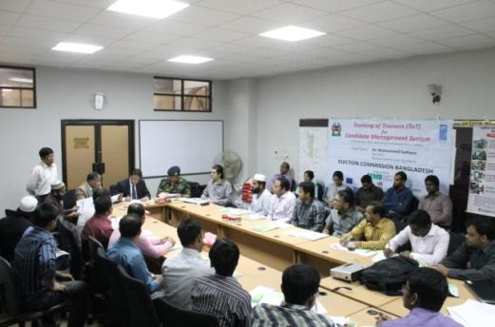 | 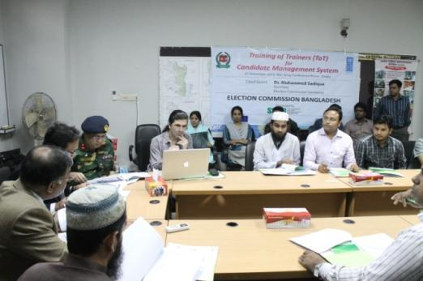

Training on Candidate Management System (CMS)

To orient field officers at ARO and RO’s office on the newly developed CMS and enhance their skills to entry and manage candidate information from submitted nomination paper, the ECB with the support from SEMB organized training on ‘Candidate Management System (CMS)’ from 22-24 November 2013. A total of 578 field officers at ARO (Assistant Returning Officer) and RO (Returning Officer) offices participated in the training programme. A total of 26 resource personnel (5 master trainers and 21 trained trainers through ToT) were engaged to impart the training among the trainees. 21 personnel from ICT wing and NID Wing of ECS were trained as trainers of CMS on 10 November 2013. Utilizing this CMS system allows managing the candidate nomination processing in automated manner and to produce relevant reports as prescribed in the election manuals.

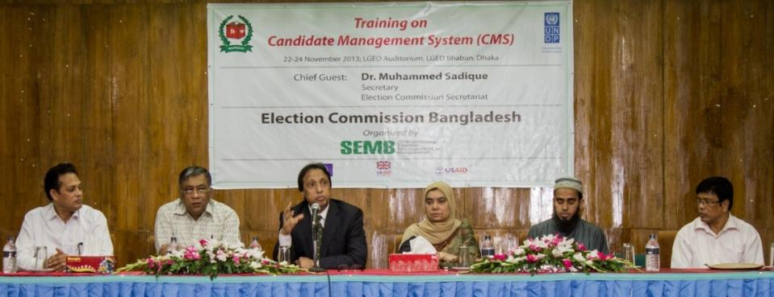 | 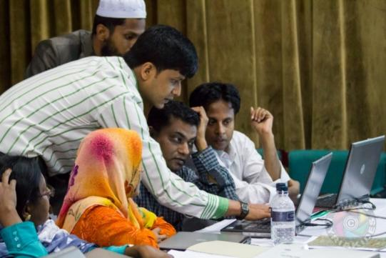
Dr Muhammed Sadique, Secretary, ECS, gives inaugural speech on CMS training

CMS can auto-generate a number of reports, including:
- List of candidates who submitted nominations;
- Credit Information Bureau (CIB), Bangladesh Bank, report for verification of loan defaulter information of candidate
- Final candidate list with allocated symbols;
- List of invalid nominations (each may be listed with RO’s/ARO’s reason for rejection);
- Generation of ad-hoc statistical reports.
- A number of these CMS auto-generated reports will be published directly in the official website of ECB.

End-of-training evaluation revealed that 62 percent of participants rated the training as excellent and 38 percent rated it as satisfactory.

Election Commissioners’ Briefing on the Results Management System (RMS)

On 6 November 2013, the ICT Wing of the Election Commission, supported by the SEMB project, presented the Results Management System to the Chief Election Commissioner (CEC) and the four Commissioners.

A demonstration of the system was provided and a lively discussion with the Commissioners followed. Both the demonstration and the discussion focused on the use of the system, its main functions and the plan for training, testing and deployment.

The CEC thanked the IT team for their work and expressed his satisfaction with the development of the system. He asked the team to move forward with their plans to ensure a timely and successful deployment of the RMS for the 10th Parliamentary polls. Prior to this meeting, the features and functions of the system were shared with the Secretary and other senior members of the Secretariat and their comments and feedback received.

The Election Commission of Bangladesh has piloted two different versions of the RMS in past sub-national elections and intended to roll out a new version for the 10th parliamentary polls. The RMS automates the election results calculations and offers an administrative tool to the ECB to enhance the efficiency and accuracy of results tabulation and the publication of final results. The RMS serves only as a tool and the manual results process remains the official and legally recognized one. The RMS will be accompanied by a Candidate Management System (CMS), which supports the more efficient management of the candidate nomination process. Both RMS and CMS has been fully developed and deployed before parliamentary elections

Training of Trainers (ToT) on RMS for polling officials

ICT team of Election Commission Bangladesh (ECB) with the technical assistance of the SEMB Project developed the Result Management System (RMS) software tobe used in the 10th Parliamentary election. RMS facilitates the entry of the result information from submitted result forms by presiding officer and processing the tabulation and other related reports.

Training of Trainers on RMS was held on 12 December 2013. The ICT teams of ECS and SEMB project conducted the ToT session. 31 personnel from ICT wing and NID Wing of ECS were trained as master trainers of RMS. These master trainers in turn trained 350 field officers at ARO and RO’s office. All ICT equipment required for deploying RMS has been procured and delivered to ECB.

Training on RMS for polling officials

To orient the newly developed RMS of field officers at ARO and RO’s office and enhance their skills to enter and manage result tabulation and processing from submitted result form by presiding officer, the ECB with the support from SEMB organized training on ‘Result Management System (RMS)’ from 25-26 December 2013. A total of 350 field officers at ARO (Assistant Returning Officer) and RO (Returning Officer) offices participated in the training programme. A total of 37 resource personnel (5 master trainers and 31 trained trainers through ToT) were engaged to impart the training among the trainees. 31 personnel from ICT wing and NID Wing of ECS were trained as trainers of RMS on 12 December 2013. Utilizing this RMS system manages the result tabulation and processing in automated manner and the production of relevant reports as prescribed in the election manuals.

The training method utilized involved demonstrating system first, followed by hands-on practice in a group. All the sessions were very interactive. Feedbacks from the participants were collected and will be analyzed subsequently. During the feedback session the majority of participants have shown an appreciation for the training method and expressed their opinion this RMS software is easily understandable and usable.

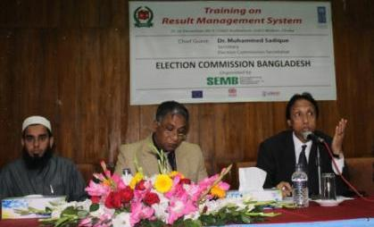 | 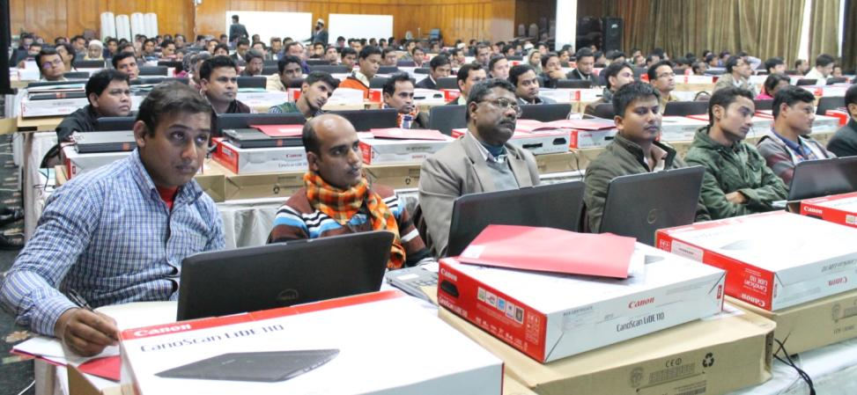

PROCUREMENT UPDATE

Ballot boxes, security seals and indelible ink pens

UNDP in line with its short-term intervention supported to Election Commission with the procurement of the following election materials for the 10th Parliamentary elections:
- 40,000 Ballot Boxes
- 2,400,000 Security Seals
- 648,000 Indelible Ink Pens

The following procurements were done for the Results Management and Candidate Management Systems:

Major Procurements – Hardware
- RMS kits: 710 Laptop Computers with backpack, security lock and USB mouse
- 100 Multifunctional Printers
- 2 Servers (1 production server and 1 development server) with Windows Server 2012 Datacenter Edition (factory installed) and SQL Server 2012 Std.
- 1 Network KVM Switch
- 710 USB powered flatbed scanners
- 1 Firewall
- 2 UPS (1.5KVA) for Servers
- 5 UPS (3KVA) with extended battery

Major Procurements – Software
- Visual Studio 2012 professional with Media Kit and License (10 Nos)
- Telerik (DevCraft Ultimate) with License (1 Nos)
- DevExpress (Universal best value) with License (1 Nos)
- Component Art Data visualization for visual studio Ultimate (Data Visualization Ultimate) with License (1 Nos)
- Visual Studio 2012 Ultimate with MSDN with Media Kit and License (1 Nos)
- 750 antivirus software packages

LESSONS LEARNED

During the reporting period UNDP learned lessons that could lead both initiatives in a more strategic positioning of future interventions. Though UNDP focused on strategic positioning itself to ensure flexibility, there are other areas that require further intervention from international community to ensure ECB’s independence as a constitutional body.

Particularly, succeeding projects can be designed to promote the sustainability of past assistance. Electoral assistance that adopts a more long-term approach to capacity development that embraces the entire electoral cycle, i.e. beyond the general election event, is more effective at building capacity and achieving sustainable results.

Use of pilot activities is an efficient way to ascertain the feasibility or effectiveness of an initiative and to address concerns prior to implementation or roll out countrywide / scaling up. Such an approach was used for voter registration and guided decision on technological innovations such as electronic voting, electronic monitoring of polling stations and results management system.

The most crucial and important findings are that despite very strong technical preparation for elections the political situation can undermine a successful outcome envisioned during the planning process. A strong consensus among political parties is a must to ensure a successful and legitimate election.

WAY FORWARD

The past year and as well as the parliamentary elections presents the opportunity for the ECB to consolidate the achievements it has made in election administration and to demonstrate its ability to deliver high-quality national elections. The interventions therefore were positioned to strategically support the plans for the parliamentary election as well as to assist greater capacity development within the ECB by further enhancing its institutional and professional capacities.

Professionalized Training

UNDP will continue to support ETI’s capacity to plan and implement trainings and will assist the delivery of training programmes and skills development for ECB staff, temporary poll workers and other electoral stakeholders. Trainings will also promote greater interaction and engagement among electoral stakeholders. Assistance will be provided to ensure the production of high quality training materials and the establishment of a system for training implementation, evaluation and monitoring. Training to further develop skills related to planning and monitoring will also be undertaken. The BRIDGE methodology will continue to be used with an ultimate goal of establishing a national pool of certified BRIDGE facilitators.

Institutional Development

UNDP will support the enhancement of ECB internal administration. A review of the status of implementation of ECB Strategic Plan (2011-2016) and Action Plan (2011-2013) will be undertaken and assistance will be provided to update the Action plan and monitor its implementation.

Communications

Priority will be placed on developing strengthened communications and stakeholder outreach. The UNDP will support the reform of the Communications Unit and development of ECB media and outreach policies and approaches. This will support the ECB’s capacity to plan and implement a communications and stakeholder engagement strategy and more effective voter education and awareness.

Strengthened ICT

Assistance will be provided to enhance the ability of the ECB to utilize ICT in election management raising its transparency and accountability. The finalization of election software and systems for results management; candidate and political party management and voter interaction systems will be supported. Pilots and trainings on these systems will take place. Capacity Development activities for the ICT wing will also be undertaken.

Decentralization of voter roll

UNDP will continue to provide assistance to ensure implementation of ECB decentralization plan of voter roll keeping the necessity of accuracy as the top priority.

FINANCIAL REPORT

Budget And Delivery By Major Heads

In 2013, the projects delivered ---- of its planned budget of USD ----------------. Other capacity and institutional development initiatives as outlined in the results of previous sections were also funded.

The below table presents the expenditure against each outcome:

OUTCOME | EXPENDITURE (USD)
Outcome 1
Outcome 2
Outcome 3
Outcome 4
Outcome 5
Total

Annex 1: Major Trainings

No | TRAINING | NUMBER OF PARTICIPANTS | DATES
 | BRIDGE module on Pre-Election Activities - batch 1 | 24 | 14-16 May, 2013
 | BRIDGE module on Pre-Election Activities - batch 2 | 23 | 04-06 June, 2013
 | BRIDGE module on Gender and Elections | 27 | 17-20 June, 2013
 | BRIDGE module on Electoral Training | 21 | 24-27 June, 2013
 | Briefing for core trainers | 25 | 1-2 November 2013
 | Training of Trainers | 1400 | 13 November 2013 - 26 December 2013
 | Training of Presiding and Assistant Presiding Officers | 114917 | 23 December 2013 - 03 January 2014
 | Training of Polling Officers | 191586 | 23 December 2013 - 03 January 2014

Annex 2: Documents and Publications

No | Title of Publication | Publication Details | Number of copies published | Time of Publishing
 | Manual on Conduct of 10th National Parliament Election | Compilation of laws, rules and regulations governing the conduct of parliamentary election for election officials and electoral stakeholders | 10,000 | December 2013
 | Trainers Guide for training of Presiding and Assistant Presiding Officers | Guidelines for trainers on methodology and contents of the training of polling officials | 3,000 | November 2013
 | Trainers Guide for training of Polling Officers |  | 3,000 | November 2013
 | Manual for Presiding and Assistant Presiding Officers | Election reference handbooks for polling officials describing essential processes and procedures during polling and counting | 300,000 | December 2013
 | Guidelines for Polling Officers |  | 500,000 | December 2013

BRIDGE (Building Resources in Democracy, Governance and Elections) is a modular professional development program with a particular focus on electoral processes. BRIDGE was jointly developed and is being maintained by the Australian Electoral Commission (AEC), International Institute for Democracy and Electoral Assistance (International IDEA), International Foundation of Electoral Systems (IFES), UNDP and United Nations Electoral Assistance Division (UNEAD).
Largely with the exception of the 9th Parliamentary elections in 2008.

